Secret in k8s
A Secret YAML file in Kubernetes is a configuration file used to define a Secret object that securely stores sensitive information such as passwords, API keys, tokens, certificates, and credentials in Base64-encoded format, and allows this data to be safely accessed by Pods through environment variables or mounted files (volumes).
A Secret is used in Kubernetes to store sensitive data like:
- Passwords
- Tokens
- API keys
- Database credentials
Unlike ConfigMap, Secrets are meant for confidential data.

Step 1: Convert credentials in Base64-encoded format
Step 2: Create Secret.yaml file use the base64-encoded format as value
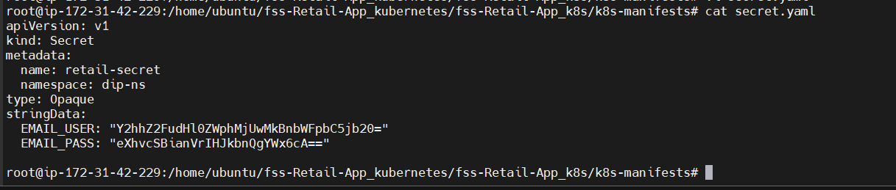
Step 4: Make change in userprofile-deployment.file use value from secret file
apiVersion: apps/v1
kind: Deployment
metadata:
name: userprofile-deployment
namespace: dip-ns
spec:
replicas: 4
selector:
matchLabels:
app: userprofile
template:
metadata:
labels:
app: userprofile
spec:
containers:
- name: usernode-js
image: saiteja2502/userprofileretail:latest
ports:
- containerPort: 3130 # Change to match your app's port
env:
- name: MONGODB_URI
valueFrom:
configMapKeyRef:
name: retail-config
key: MONGO_URL
- name: SESSION_SECRET
valueFrom:
configMapKeyRef:
name: retail-config
key: SESSION_SECRET
- name: EMAIL_USER
valueFrom:
secretKeyRef:
name: retail-secret
key: EMAIL_USER
- name: EMAIL_PASS
valueFrom:
secretKeyRef:
name: retail-secret
key: EMAIL_PASS
- name: PORT
valueFrom:
configMapKeyRef:
name: retail-config
key: PORT

Step 6: Deploying resources

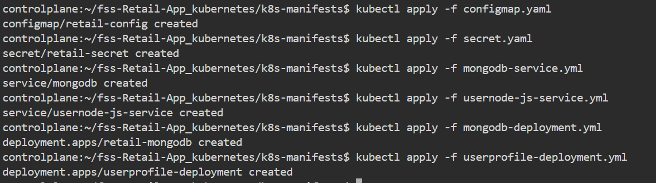
Step 7: Checking Status
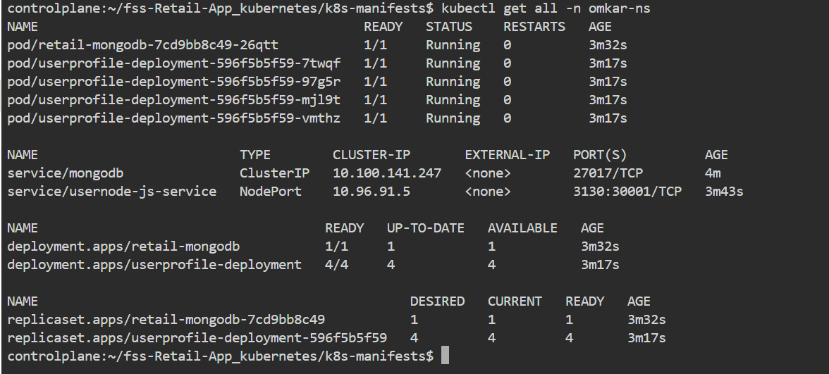

Step 8: Getting Nodes
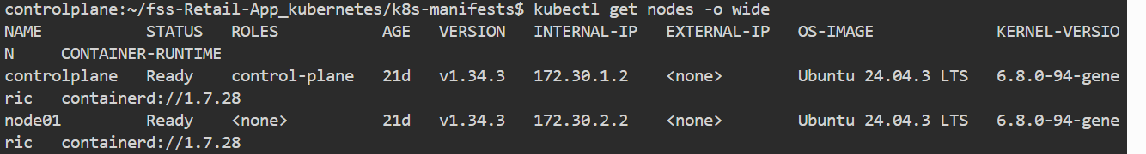

Step 9: Checking is it running using terminal

